### Contract Processing Steps *(Entire Section: Implementation/Success to fill Post-Go Live)*

### **If the contract looks like the screenshot below, follow the steps, use the red font as a guide to where to find information**

**Example of Order Template of Data Services and Fees (**[**Garage example**](https://garage.tabsplatform.com/prod/contracts/4361748e-203d-4431-aee6-7f06286054c4/terms/revenue)**)**

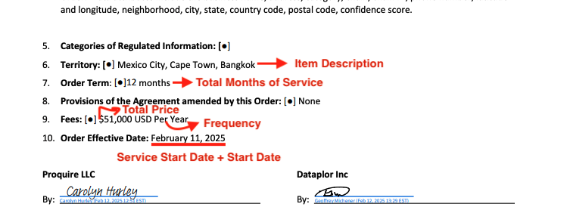

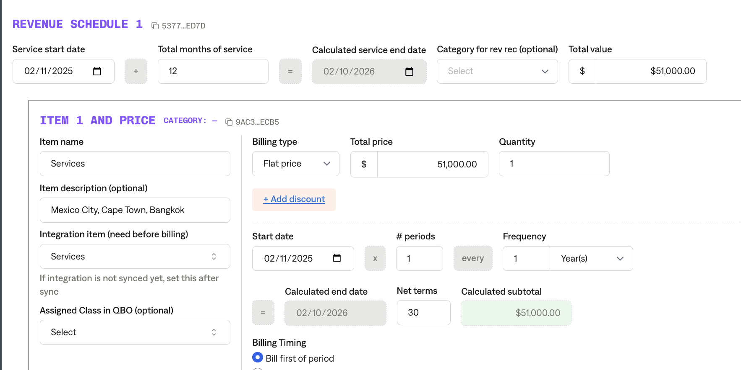

**Service Start Date:** Order effective date

**Months of Service:** Refer to the order term

**Item Name:** Fees

**Item Description:** Include the countries listed (or anywhere that lists the countries/territories that are included)

**Integration Item:**

**Billing Type:** Flat

**Total Price:** Listed in fees or search contract for where fees are listed

**Quantity :** Default 1  **Start Date:** Order effective date

**Periods:** a lot of these contracts are yearly but verify that the contracts states if it is just a one time charge

**Frequency:** a lot of these contracts are yearly but verify if the contract states yearly or monthly

**Example of REPRESENTATIONS contract (**[**Garage Example**](https://garage.tabsplatform.com/prod/contracts/2cf095cd-5d3e-480f-80d4-82c3bfad3a66/terms/revenue)**)**

**If the contract looks like the screenshot below, follow the steps, use the red font as a guide to where to find information**

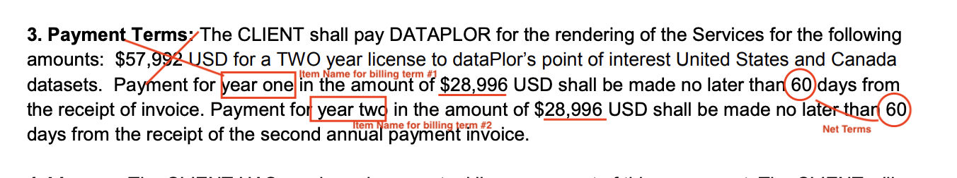

**Service Start Date:** Date listed in contract (will usually be in the first paragraph of the contract)

**Months of Service :** Recognize each billing term for the whole entire term of contract (example for this contract 24 months)

**Item Name:** Title it “year 1” or “year 2” if there are multiple payments

**Item Description**

**Integration Item**

**Billing Type:** Flat

**Total Price:** See the individual price for each year, not the total price

**Quantity :** default 1 **Start Date :** Start date for first year will be based on the service start date

For year 2, do 1 year after the start date or read the wording in the contract to figure out when the second payment is due

**Periods:** default 1

**Frequency:** See PAYMENT TERMS section and see how long the contract is, for this example

they are dividing it into two payments each year

**One off examples:**

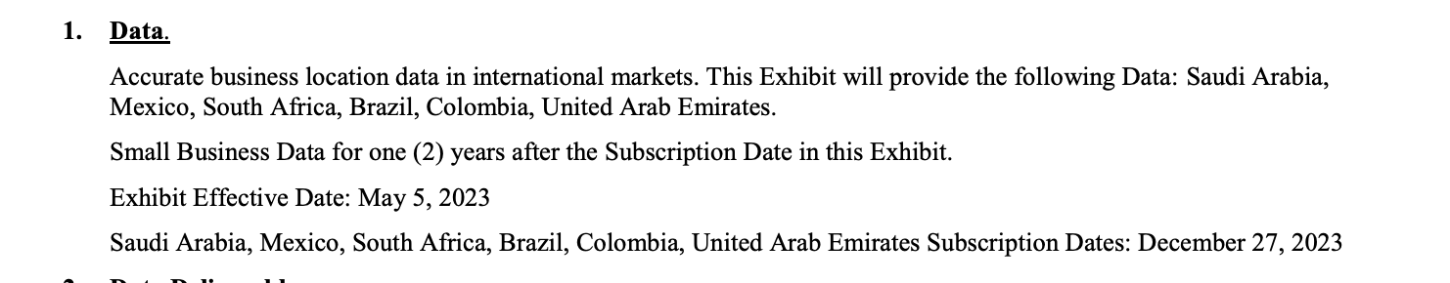

**If there is an EXHIBIT date, you will use that date as the Service Start Date and have the term end based on the subscription date.** Example: May 5th, 2023- December 27th, 2025

1. Default Service Term
   1. If None Listed, Ops Default is 1 Year
2. Default Net Payment Terms
   1. If None, Ops Default is 0
3. Default Billing Frequency
   1. If None Listed, Ops Default is Monthly
4. How do we handle taxes as a line item?
   1. If None Listed, Ops Default is every tax line item becomes a BT